**Spike:**  *21*

**Title:** Measuring Performance

**Author:** Steven Efthimiadis, 1627406

**Goals / deliverables:**

Write a short report on measuring the performance of the Unreal Engine. Then create another short report on the performance difference between 100 dynamic verses 100 baked lights. Compare and report the difference.

To create this spike, you require:

* Use Spike 16 as a reference
* Performance measuring

**Technologies, Tools, and Resources used:**

List of information needed by someone trying to reproduce this work

* Performance Measuring
  + <https://docs.unrealengine.com/latest/INT/Engine/Performance/index.html>

**Tasks undertaken:**

* Add a couple of Actors (Shapes are good)
* Create a few materials
* Add to the project
* Create the blueprints

**What we found out:**

* You can either the collision to be what type you want you want if you click on the mesh in the ui.

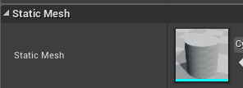 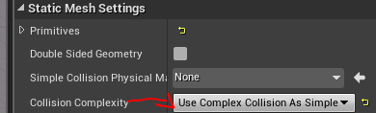

**Open issues/ risks:**

* Trying to change the material on collision was harder than expected. If you have any trouble, there are a few pictures of who you should look at it

